 | Green Discourse:  Journal of Ecolinguistics  and Ecocriticism | e-ISSN: XXXX-XXXX  p-ISSN: XXXX-XXXX  Vol. 1 No. 1 (2026)  https://greendiscourse.bumi-spasial.com

Urban Green Mosaic: A Geo-Overlay Analysis of Land Use and Green Space Distribution (GOS) For Sustainability City in Banjarmasin, South Kalimantan

Eva Nurrahmi Lukman*¹, Alief Saputro², Badrizal Al Hazar³, Annisa Putri⁴
¹Geography Study Program, Faculty of Social and Politicial Science, Lambung Mangkurat University, Indonesia
^{2,3} Geography Education Study Program, Faculty of Mathematics and Natural Sciences, Makassar State University, Indonesia
⁴ Department of Geography, Faculty of Social Sciences, Padang State University, Indonesia
ARTICLE INFO |  | ABSTRACT
Article type  Research Article  Keywords  Green Open Space; Land Use; Overlay Analysis; GIS  Article history  Received: 05 April 2026  Revised: 15 May 2026  Accepted: 20 May 2026  Published: 30 June 2026  OPEN ACCESS  Copyright © 2026 The Authors. Published by Bumi Spasial Publisher. |  | Green open spaces (GOS) are fundamental to sustaining ecological stability in rapidly urbanizing regions; however, their spatial configuration and ecological performance are closely shaped by land-use intensity. In Banjarmasin, a densely populated riverine city, contrasting development pressures across districts provide a relevant context for examining how urbanization affects the fragmentation, size, and connectivity of the green spaces. This study employed a descriptive–quantitative geospatial approach by integrating multisource satellite imagery (Sentinel-2 MSI, Landsat 8/9 OLI/TIRS, and high-resolution Google Earth Pro), administrative boundaries, GOS inventories, and systematic field verification to ensure classification accuracy. Spatial overlay analysis revealed pronounced ecological disparities: Central and Southern Banjarmasin, dominated by commercial areas, dense residential clusters, industrial zones, and port activities, exhibited small, fragmented, and weakly connected GOS with limited ecological functionality. Conversely, Northern Banjarmasin, characterized by agricultural land and low-density suburban development, contains larger, coherent green patches that function as ecological buffers. These findings indicate that higher development pressure leads to increased fragmentation and reduced ecological connectivity, whereas lower-intensity land uses support more resilient green structures. The study concluded that strengthening ecological corridors, integrating micro-scale vegetation, and enhancing inter-district connectivity are essential for improving urban landscape resilience.
*Corresponding author
Introduction
Urbanization in Banjarmasin has intensified in recent years, exerting increasing pressure on the city’s ecological system. With an area of only 98.47 km² and a population density of 6,779 inhabitants/km², Banjarmasin is one of the most densely populated cities in South Kalimantan (Pemerintah Kota Banjarmasin, 2022). Continued population growth, particularly in the South Banjarmasin District, which recorded a 1.13% increase in 2023, further drives the demand for the expansion of built-up land within very limited urban space (Pemerintah Kota Banjarmasin, 2023). This situation accelerates land-use change and reduces the natural spaces that play important ecological roles in the city (McGarigal et al., 2012). The conversion of wetlands into built-up areas in lowland cities has been shown to increase surface runoff, shorten the time of concentration, and heighten flood risks. The conversion of wetlands into built-up areas in lowland cities has been shown to increase surface runoff, shorten the time of concentration, and heighten flood risks (Mitsova et al., 2011). In Banjarmasin, whose landscape is morphologically dominated by swamps and river corridors, these characteristics indicate a natural capacity to function as a water-retention landscape or “urban sponge.” However, ongoing land-use transformation raises an important spatial question: whether the current distribution of built-up areas and Green Open Spaces (GOS) still reflects this ecological function or instead indicates increasing ecological pressure. As emphasized by McDonald (2009), unregulated urbanization in flood-prone cities often leads to declining infiltration capacity, loss of ecological buffers, and degradation of ecosystem services. In this context, land-use change in Banjarmasin is not only a matter of urban growth but also a spatial reconfiguration that may shift water-absorbing surfaces into impervious built-up dominance. Therefore, examining the spatial relationship between land-use patterns and the distribution of GOS is essential to empirically assess whether the city’s landscape configuration still supports its hydrological role or shows signs of ecological overload. These challenges are more complex because Banjarmasin is geographically dominated by swamp ecosystems and riverbank areas that naturally function as water-retention zones and hydrological regulators (Alshammari et al., 2023).
The conversion of wetlands and vegetated land into built-up surfaces increases impervious areas, reduces soil infiltration capacity, and accelerates surface runoff (Öztürk et al., 2024). Consequently, the potential for urban inundation and flooding increases, particularly in low-lying swamp cities such as Banjarmasin (Ridwan & Sarjito, 2024). Simultaneously, the provision of public Green Open Space (GOS) in Banjarmasin remains far below the required standard. Empirical findings show that public GOS covers only approximately 1.9% of the total city area, indicating a serious gap between spatial planning policy and its implementation at the local level (Khoiriyah, 2025). In addition to their limited extent, existing green spaces are mostly fragmented and small in size, which reduces their ecological performance (Agustiyara et al., 2025). In swamp-based cities such as Banjarmasin, green open spaces should not be viewed merely as aesthetic urban elements but as ecological infrastructure that supports water retention, runoff control, environmental quality improvement, and urban thermal comfort (Benedict & McMahon, 2006; European Environment Agency, 2023). Vegetated and permeable surfaces increase infiltration and reduce impervious cover, thereby regulating urban hydrological responses (Alshammari et al., 2023; McGarigal et al., 2012). Green spaces also contribute to reducing surface temperatures and mitigating the urban heat island effect (Liu & Zhang, 2025).
Recent spatial studies have widely employed GIS and remote sensing to map land-use change, urban expansion, and the extent of Green Open Space (GOS) in rapidly growing cities, including studies conducted in Banjarmasin (Agustiyara et al., 2025). These studies primarily provide descriptive inventories by quantifying GOS coverage, mapping its distribution, or assessing compliance with spatial planning standards. However, such approaches tend to treat land use and GOS as separate spatial entities and rarely examine how their spatial configuration functionally interacts with the ecological structure of the city. Consequently, limited attention has been paid to whether the current arrangement of built-up areas and green spaces still supports the hydrological and ecological role of cities characterized by wetland morphology. This study addresses this limitation by not only mapping land use and GOS independently but by spatially integrating both layers through geo-overlay analysis to identify spatial congruence and mismatch between them as indicators of ecological pressure. Therefore, the relationship between land-use patterns and the spatial distribution of GOS was examined using a functional GIS-based overlay approach rather than a conventional descriptive mapping perspective. Based on these problems, this study aims to (1) map the current patterns and distribution of land use in Banjarmasin City, (2) analyze the availability and spatial distribution of public GOS, and (3) conduct a geo-overlay analysis to identify spatial congruence and incongruence between land use and GOS.

Literature Review
Urban green space research increasingly emphasizes that ecological performance is determined not only by the total area of green space but also by its spatial configuration, connectivity, and relationship with surrounding land uses. Benedict and McMahon (2006) conceptualize green space as ecological infrastructure that supports hydrological regulation, environmental quality, and landscape resilience, while Tzoulas et al. (2007) further argue that its ecological value depends on functional quality, scale, and spatial continuity rather than mere presence. In rapidly urbanizing cities, the conversion of wetlands and vegetated surfaces into impervious built-up areas reduces infiltration capacity, accelerates runoff, and increases flood vulnerability (Mitsova et al., 2011; Alshammari et al., 2023), whereas fragmented green patches tend to provide weaker ecological functions than larger and better-connected networks (McGarigal et al., 2012; Wu, 2013). Forman (2014) and Turner et al. (2015) explain that development intensity influences patch size, continuity, and ecological connectivity, suggesting that dense commercial, residential, industrial, and transportation zones are likely to generate smaller and more isolated green spaces. Conversely, lower-intensity suburban and agricultural landscapes generally retain larger ecological patches and stronger regulatory functions. Although previous GIS and remote-sensing studies have effectively mapped land-use change and quantified green-space coverage, many have treated land use and green open space as separate spatial entities, thereby providing limited explanation of their functional interaction. Therefore, a geo-overlay approach is needed to synthesize both layers and identify spatial congruence, ecological fragmentation, and functional mismatch between built-up areas and green-space distribution, particularly in wetland-based cities such as Banjarmasin.
Methodology
This study employed a descriptive–quantitative geo-spatial analytical framework to delineate the configuration of land-use patterns and the spatial distribution of Green Open Spaces (GOS) in Banjarmasin City. The study site, Banjarmasin City, was selected because of its critical scarcity of Green Open Space (GOS) relative to statutory targets and its distinctive riverine urban form, which shapes land-use dynamics and spatial patterns. Previous research has documented that the availability of GOS in Banjarmasin is substantially below the minimum 30 % of the total area stipulated in Indonesian spatial planning regulations (Rahman & Kojima, 2017; Rif’ati & Idajati, 2022), with some central city areas reporting only approximately 5.13 % GOS (Rahman & Kojima, 2017). Moreover, Banjarmasin’s development along interconnected river systems characterizes its urban landscape, intensifying built-up expansion alongside limited green space provision and reinforcing the relevance of a geospatial analytical approach (Caesarina & Rahmani, 2020).
The methodological architecture is grounded in the principles of spatial thinking within Geographic Information Systems (GIS), as articulated by Goodchild (2007), which conceptualizes spatial relations—proximity, connectivity, and morphological patterning–as fundamental analytical units for deciphering the trajectories of urban landscape transformation. The dataset comprises primary data obtained through rigorous ground verification to substantiate the interpretive outputs and ensure high positional fidelity, alongside secondary datasets, including medium- to high-resolution satellite imagery (Sentinel-2 MSI, Landsat 8/9 OLI/TIRS, and very-high-resolution Google Earth Pro scenes), administrative boundaries, GOS inventories, and demographic records. The integration of these multisource datasets enhances the analytical robustness by synthesizing spectral information with empirically grounded field observations. The research location is shown in the image below.
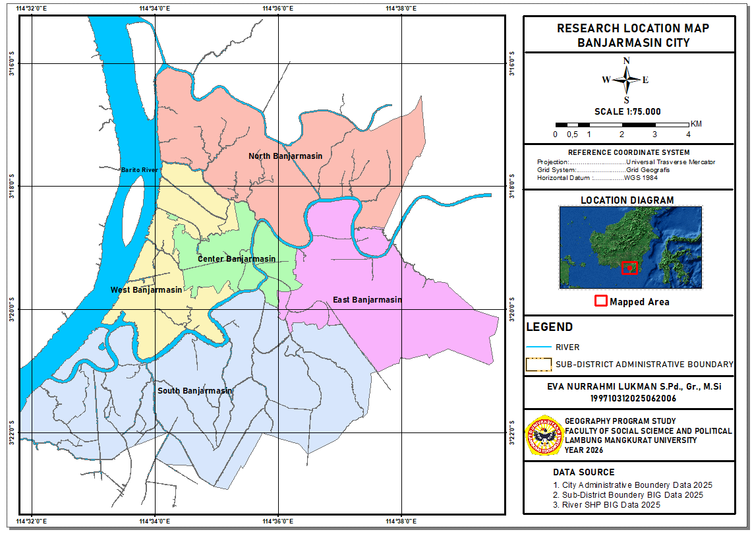
Figure 1. Research Location
Land use and GOS identification were executed through meticulous visual image interpretation guided by object-based parameters, including tone, texture, spatial patterning, geometric form, dimensional attributes, and contextual association, following the remote-sensing framework of Lillesand and Kiefer (2015). The interpretive outputs were subsequently transposed into vector representations via on-screen digitization in ArcGIS Pro, yielding standardized feature layers suitable for advanced spatial interrogation. The core analytical procedure employs a suite of geo-overlay operations (intersect, union, dissolve, and identity) to integrate and evaluate the spatial interdependencies between the land-use surfaces and GOS layers. This overlay mechanism facilitates the detection of spatial congruence, identification of functional mismatches in land allocation, assessment of ecological fragmentation intensity, and delineation of zones undergoing anthropogenic pressure and potential land conversion.

Result
- General Conditions of Land Use in Banjarmasin City in 2025
The following table presents the results of the land use classification of Banjarmasin in 2025 based on field verification. This data shows the dominance of low-density settlements (0.002937 km²), medium-density settlements (0.000833 km²), and trade, industry, and warehousing functions spread along the river corridor, with a length of 4,761,039 m. This pattern serves as an important basis for understanding how land structure forms spatial pressures on the availability of GOS, which is then analyzed through overlay.
Land Use | Area (m²) | Length (m)
Low Density Housing | 0,002937 | 2,683747
Medium Density Housing | 0,000833 | 0,939016
River | 0,000673 | 4,761039
Trade and Services | 0,000414 | 1,850246
Industry | 0,000403 | 0,457501
Port Location | 0,000249 | 0,288158
Sustainable Agriculture | 0,00026 | 0,178457
Agricultural land | 0,000191 | 0,173632
Warehousing | 0,000184 | 0,187824
High Density Housing | 0,000135 | 0,181858
Courtyard and Street | 0,000113 | 2,511592
Education Services | 0,00007 | 0,211364
Office | 0,00004 | 0,162103
Tourist | 0,000019 | 0,019154
Access Health Services | 0,000018 | 0,037972
National Defense | 0,000027 | 0,080887
National Defense | 0,000032 | 0,042583
Final Processing Place | 0,000003 | 0,043688
Worship | 0,000005 | 0,040535
Cultural heritage | 0,000005 | 0,020202
Table 1. Land-Use Classification of Banjarmasin City in 2025.
Source: Field observation results 2025
The land use composition in the table shows that most of the city's space has been occupied by built-up areas, while land with the potential to function as ecological buffers, such as agriculture (0.000191 km²) and sustainable agriculture (0.00026 km²), is limited. This condition indicates a potential spatial imbalance between land use intensity and the availability of ecological space, which was further analyzed using an overlay map of land use and GOS. Land-use categories across the study area were identified through spatial classification and GIS-based mapping. The resulting land-use distribution across Banjarmasin is shown in Figure 2.
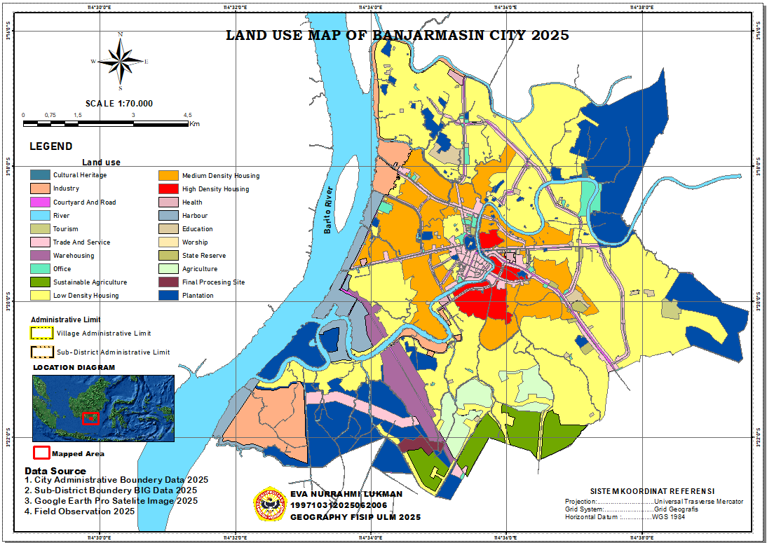
Figure 2. Mapping of Land Use in Banjarmasin City.
Source : Spatial analysis for 2025

- Analysis of the Availability of Green Open Space in Banjarmasin City
The availability of Green Open Space (GOS) in Banjarmasin City in 2025, based on the results of spatial mapping and field verification,is shown in Figure 3. This map shows the distribution and spatial pattern of public green open spaces spread across five sub-districts, with a tendency towards small, fragmented units in dense residential areas and the city center, as well as several large green pockets in the northern part of the city.
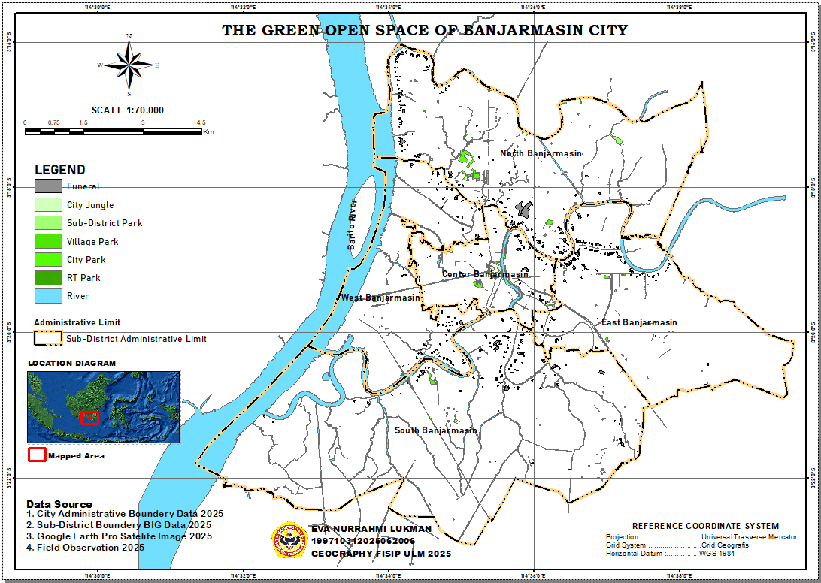
Figure 3. Mapping of GOS availability in Banjarmasin.
Source: Spatial analysis for 2025.
The visualization results show that GOS in Banjarmasin are generally present as small, fragmented patches in densely built-up areas, whereas large green spaces are concentrated in areas with lower land-use pressure. This pattern shows the dominance of micro-scale parks (RT/sub-district parks and small-sized city parks) in the city center, as well as the presence of large-scale parks in northern Banjarmasin (±25.99 ha and ±17.94 ha) that serve as ecological cores. This confirms that the distribution of Green Open Space is not random, but rather follows the intensity of space use.
- Overlay analysis of Land Use and availability of Green Open Space (GOS)
To understand how land-use intensity shapes the ecological structure of the city, the land-use and Green Open Space (GOS) maps were spatially integrated using geo-overlay operations. This process does not merely superimpose two thematic layers but reveals how the spatial configuration of built-up areas interacts with the distribution, size, and connectivity of green spaces across urban landscapes. The resulting overlay map provides a functional spatial perspective for identifying areas where ecological performance is supported or constrained by the prevailing land-use patterns. Overlay analysis enables the identification of how built-up areas, river networks, and existing Green Open Spaces interact spatially within the urban structure. This spatial configuration and distribution pattern derived from the GIS overlay process are illustrated in Figure 4.
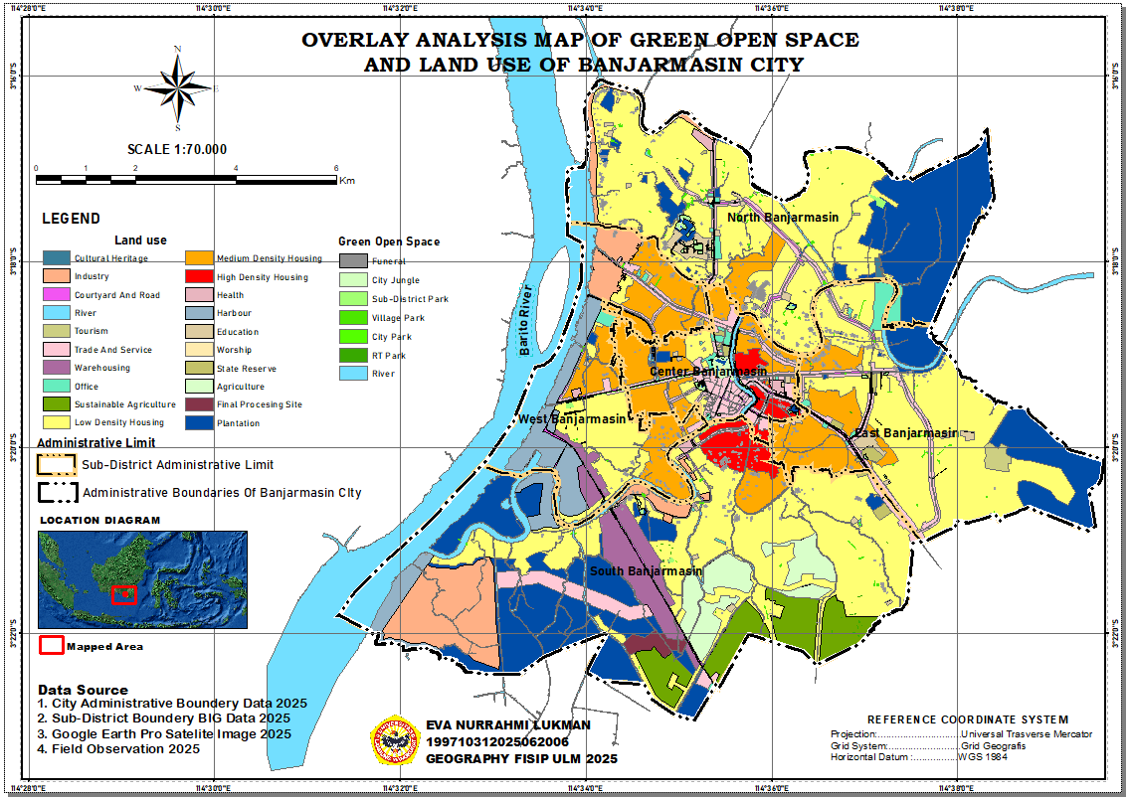
Figure 4. Mapping the Availability of Green Open Space and Land Use.
Source: Spatial overlay analysis results, 2025.
Discussion
General Conditions of Land Use in Banjarmasin City in 2025
Land-use patterns in Banjarmasin for 2025 reveal a dominant residential footprint with varying density classes, reflecting spatial expansion consistent with urban sprawl characteristics widely documented in Southeast Asian metropolitan studies (Herold et al., 2003; Seto et al., 2012). The concentration of settlement growth along riverbanks and wetland zones indicates an adaptive morphology typical of delta and wetland cities, aligning with hydrology-driven urban development frameworks that emphasize water systems as the primary determinants of urban. Expansion into hydrologically vulnerable areas simultaneously elevates exposure to tidal flooding and river overflow phenomena, frequently reported when natural drainage capacity diminishes in rapidly developing deltaic environments.
Open spaces, agricultural land, and sustainable farming patches continue to function as ecological buffers supporting urban hydrological regulation. However, escalating development pressure has induced landscape fragmentation and reduced green-patch connectivity, a trend consistent with the ecological theory linking fragmentation to declining stability in urban ecosystems (Forman & Godron, 1986). River bodies, covering approximately 0.000673 km², remain key structural elements, yet observable sedimentation, channel constriction, and bank degradation indicate increased anthropogenic stress. These conditions reinforce the need for river-basin-scale management strategies to secure long-term hydrological resilience.
The spatial distribution of public facilities appears relatively balanced, reflecting theoretical expectations regarding the allocation of essential services across urban centers (Christaller, 1933). Meanwhile, the clustering of economic functions along major accessibility corridors, both terrestrial and riverine, parallels location-allocation models that emphasize accessibility as a driver of economic spatial patterns (Alonso, Bid-rent model, 1964). The port area, covering 0.000249m², further consolidates Banjarmasin’s role as a logistical hub within the regional river transport network. In contrast, the minimal extent of cultural-heritage zones (0.000005m²) indicates the limited integration of historical assets into the urban spatial structure, an issue frequently highlighted in urban-conservation frameworks (Forman & Godron, 1986). Overall, the city’s 2025 spatial configuration illustrates simultaneous pressures from urbanization, ecological degradation, and functional imbalance, underscoring the need for adaptive and ecologically grounded planning to ensure sustainable urban development. The spatial pattern of land use in the study area reveals the integration of traditional economic activities with formal urban functions in the area. Figure 5 illustrates how traditional market activities and office buildings occupy adjacent spaces along the same corridor in Banjarmasin.
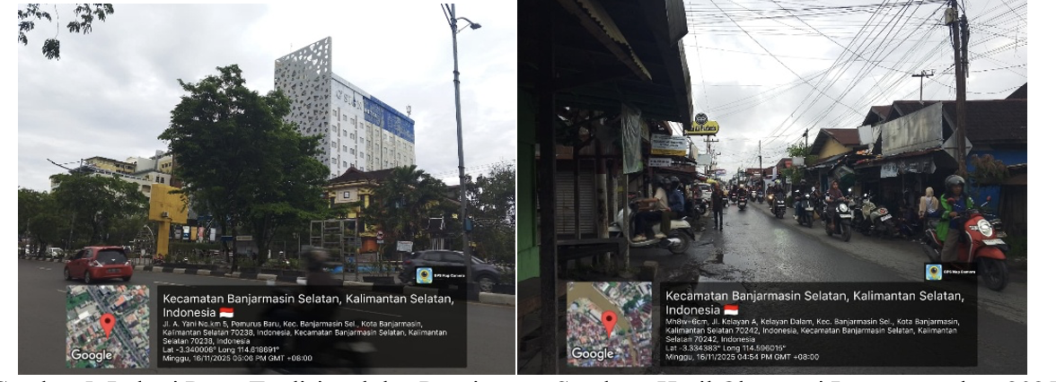
Figure 5. Land use for traditional markets and offices:
Source: Field Observation, 2025
Availability of Green Open Space in Banjarmasin City
Based on field observations, the configuration of Green Open Space (GOS) in Banjarmasin City in 2025 reveals a dynamic spatial pattern characterized by considerable variations in form, function, and scale across its five administrative districts. The spatial distribution indicates that most GOS areas consist of small, scattered units located within densely populated residential neighborhoods and central urban zones, whereas larger green spaces appear only in specific areas, particularly in North Banjarmasin. Central Banjarmasin exhibits the highest concentration of GOS points, dominated by urban parks ranging from 0.001 to more than 1-ha in size. The prevalence of these microscale green spaces reflects a micro-greening approach commonly implemented in high-density urban environments (Jim & Chen, 2006). This pattern also aligns with the concept of patch dynamics, which emphasizes the ecological significance of small spatial patches functioning collectively as interconnected urban ecological mosaics (Wu, 2013). Although relatively limited in size, urban forests and burial grounds in this district contribute additional ecological value. Green Open Spaces in South Banjarmasin are distributed in the form of neighborhood parks and recreational areas which serve both environmental and public activity functions. The actual conditions and spatial characteristics of the GOS locations are illustrated in Figure 6.
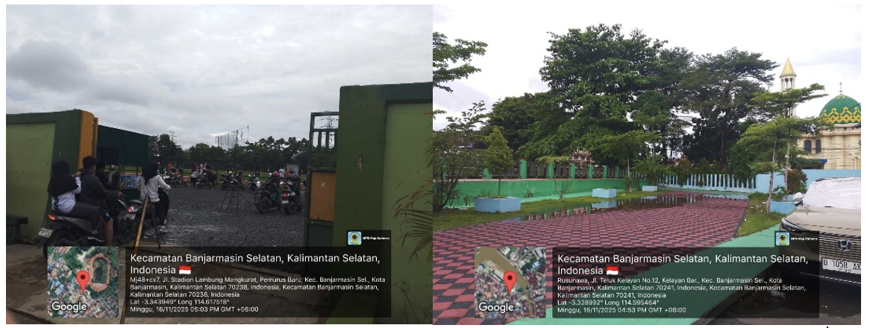
Figure 6. Green Open Space (City Parks and Recreational Parks).
Source: Field Observation, 2025
Green Open Spaces in South Banjarmasin are distributed in the form of neighborhood parks and recreational areas that serve both environmental and public activity functions. The actual condition and spatial characteristics of these GOS locations are illustrated in Figure 6In contrast, North Banjarmasin demonstrates the strongest ecological capacity. This is reflected in the presence of a large sub-district park covering 25.99 hectares and a neighborhood-level green space of 17.94 hectares, collectively forming the core GOS elements. These larger green areas function as essential ecological buffers, supporting key environmental processes in line with the Urban Ecological Infrastructure (UEI) framework, which underscores the role of extensive green networks in sustaining ecological performance and ecosystem services in urban settings (Benedict & McMahon, 2006; Beatley, 2011). South Banjarmasin, on the other hand, faces a notable deficiency in functional public green spaces.
Urban forests are nearly absent, and only a limited number of kelurahan parks and urban parks are available. The largest green areas in this district are burial grounds, which, although categorized as GOS, provide limited ecological and recreational benefits. This situation reflects the findings of Tzoulas et al. (2007), who emphasized that the ecological value of GOS depends not only on its existence but also on its functional quality and spatial scale. Overall, the GOS structure of the city is dominated by small, fragmented green patches. Such ecological fragmentation (Wu, 2013) increases the city’s vulnerability to flooding, surface temperature rise, and declining air quality owing to the absence of large, cohesive green cores capable of delivering broader ecological functions. To meet the national requirement of a minimum of 30% GOS, as mandated by the Indonesian Spatial Planning Law No. 26/2007, Banjarmasin must adopt an integrated ecological planning strategy to ensure sustainable development. This includes expanding core green areas, strengthening green corridors to improve landscape connectivity, and enhancing the ecological performance of existing micro green spaces.
Overlay analysis of Land Use and availability of Green Open Space (GOS)
The spatial overlay between the Green Open Space (GOS) layer and the 2025 land-use dataset of Banjarmasin revealed a pronounced dependence of the city’s ecological configuration on the degree of land-use intensification. The integrated spatial output demonstrated a clear differentiation between densely developed urban districts and the more rural–suburban perimeter of the city. Highly built-up zones are characterized by the presence of small, isolated green patches, whereas peripheral areas with lower development pressures sustain larger, more cohesive green units. This pattern is consistent with central assertions in landscape ecology that urban development intensity governs patch size, structural continuity, and ecological connectivity across metropolitan landscapes (Forman, 2014; Turner et al., 2015).
In the central district of Banjarmasin, the overlay indicates a concentration of commercial establishments, administrative functions, educational facilities, and medium- and high-density residential complexes. Within this configuration, limited spatial availability constrains the emergence of substantial green spaces, resulting in micro-scale greens, such as neighborhood parks, subdistrict greens, and pocket gardens, typically occupying less than one hectare. These units exemplify a micro-greening response commonly documented in compact cities, where vegetation is opportunistically incorporated into residual urban spaces under conditions of intense spatial competition (Jim & Chen, 2006). The high degree of fragmentation observed in the overlay aligns with patch dynamics theory, which posits that dense urban morphologies produce mosaics of ecologically restricted patches with minimal connectivity (Wu 2013). Consequently, these small and discontinuous green units contribute only marginally to ecological functioning, reflecting the low permeability of heavily urbanized surfaces (Alberti 2016).
Land-Use Category | Dominant Land-Use Characteristics | GOS Characteristics Identified from the Overlay | Ecological Implications
Commercial and Service Areas | High-density built structures; intensive economic activity | Small urban parks (<1 ha), micro-scale neighborhood green spaces, residual vegetation patches | High spatial fragmentation; limited connectivity; low ecological functionality
High-Density Residential Areas | Extremely dense built-up fabric; minimal vacant land | Discontinuous micro-GOS; scattered vegetation | Low ecological permeability; elevated risk of urban heat islands and surface runoff
Low-Density Residential Areas | More dispersed housing; availability of open spaces | Medium-sized neighborhood parks; potential green corridors | Greater opportunity for ecological connectivity
Agricultural and Suburban Areas | Low development pressure; large unbuilt tracts | Large-scale GOS, including district parks (25.99 ha) and extensive neighborhood parks (17.94 ha) | Presence of large ecological patches; enhanced hydrological and thermal regulation
Industrial and Warehousing Zones | Large building footprints; impervious surfaces | Minimal functional GOS; mostly non-structural vegetation | Severe fragmentation; poor air-quality regulation; increased runoff
Port and Transportation Infrastructure | Hard infrastructure; high mobility intensity | Very limited GOS; non-functional green elements | High UHI potential; negligible ecological contribution
Educational and Administrative Areas | Structured development patterns; organized spatial layout | Ornamental micro-GOS; linear tree rows | Moderate shading function but limited ecological performance
Tourism and Recreational Areas | Public-oriented spaces; leisure activities | Semi-green open spaces; thematic parks | Potential integration of micro-GOS into larger ecological corridors
Table 2. Synthesis overlay between GOS and land use in Banjarmasin.
Source : Spatial overlay analysis results 2025
A markedly different spatial structure emerged in North Banjarmasin. Large tracts of agricultural land, sustainable farming areas, and low-density residential developments dominate this district, collectively yielding a landscape with reduced spatial pressures. The overlay reveals the presence of substantial GOS elements, including a 25.99-ha subdistrict park and a 17.94-ha neighborhood green, which function as the principal ecological anchors of the city. These contiguous green units illustrate the operational characteristics of Urban Ecological Infrastructure (UEI), in which interconnected spatial networks support hydrological regulation, thermal moderation, and air quality enhancement (Benedict & McMahon, 2006; Beatley, 2011). The spatial coherence of greenspaces detected in this district reinforces the evidence that suburban and peri-urban environments accommodate more structurally intact ecological systems than compact urban cores (Tzoulas et al., 2007).
South Banjarmasin has the greatest ecological constraints. The overlay revealed that the district was dominated by industrial estates, warehousing activities, port-related functions, and high-density housing. Under these conditions, functional GOS is virtually absent, with cemeteries constituting the only significant green areas, although their ecological contribution remains limited. The scarcity of urban forests, formal parks, or managed green spaces reflects the impact of extreme land-use pressure, a phenomenon frequently associated with the suppression of structural green spaces and increased ecological fragmentation in industrialized urban landscapes (Herold et al., 2003). Consequently, this district exhibits heightened ecological vulnerability, including elevated flood risk, intensified urban heat island effects, and deteriorating ambient air quality.
Collectively, the overlay analysis highlights two overarching spatial trends. First, districts characterized by high built-up intensity consistently produce green areas that are small-scale, highly fragmented, and poorly connected. Second, zones with low-to-moderate levels of development pressure can sustain larger and more structurally coherent green spaces with meaningful ecological functions. These findings reaffirm the broader spatial planning and geographic perspectives that identify land-use structure as a central determinant of urban ecological capacity (Longley et al., 2015; McGarigal et al., 2012). Strengthening ecological connectivity, particularly through the development of green corridors and the strategic integration of micro-scale green spaces with larger ecological cores, represents a critical planning priority for addressing the pronounced ecological disparities that characterize Banjarmasin’s urban landscape.

Conclusion
The integrated overlay of Banjarmasin’s 2025 Green Open Space (GOS) map and land use configuration indicated that the intensity of spatial development is the primary determinant of the city’s ecological performance. Highly urbanized districts, particularly Central and Southern Banjarmasin, are dominated by commercial activities, dense housing, industrial zones, and port infrastructure, which collectively generate small, fragmented, and weakly connected green spaces, thereby limiting ecological permeability and functionality. In contrast, Northern Banjarmasin, characterized by rural–suburban land use, accommodates larger and more coherent GOS patches aligned with Urban Ecological Infrastructure principles that enhance urban ecosystem stability.
These outcomes reinforce key landscape ecology concepts, demonstrating that urban development pressure shapes patch size, continuity, and ecological resilience, while underscoring the necessity of strengthening cross-district ecological connectivity to maintain environmental capacity. Given the limitations of this study, future research should incorporate temporal assessments of GOS changes, evaluate vegetation quality using satellite-derived indices such as NDVI or EVI, and apply spatial metrics (e.g., FRAGSTATS) to quantify fragmentation. Integrating predictive urban growth models (CA–Markov, SLEUTH, InVEST) and socio-economic analyses of green-space accessibility will also be essential for addressing spatial equity and for designing ecological corridors linking major green nodes from the northern area to the central and southern district

Funding Declaration
This research did not receive any specific grants from any funding agency in the public, commercial, or not-for-profit sectors.

Competing Interests
The author(s) declare (s) no conflict of interest.

Data Availability
The datasets used in this study consisted of satellite imagery (Sentinel-2 MSI, Landsat 8/9 OLI/TIRS, Google Earth Pro), administrative boundary data, Green Open Space inventory data, and field observation records. These data are publicly accessible from official geospatial platforms and government sources, whereas the processed spatial datasets generated during the analysis are available from the corresponding author upon reasonable request.

Declaration of AI-Assisted Technologies
The authors declare that AI-assisted tools were used only to support language editing, proofreading, and improving the clarity of the manuscript. The authors take full responsibility for the content, accuracy, originality, interpretation, and integrity of the final manuscript.

References
Agustiyara, A., Mutiarin, D., Nurmandi, A., Kasiwi, A. N., & Ikhwali, M. F. (2025). Mapping urban green spaces in Indonesian cities using remote sensing analysis. Urban Science, 9(2), 23. https://doi.org/10.3390/urbansci9020023
Alberti, M. (2005). The effects of urban patterns on ecosystem function. International Regional Science Review, 28(2), 168–192. https://doi.org/10.1177/0160017605275160
Alonso, W. (1964). Location and land use: Toward a general theory of land rent. Harvard University Press.
Alshammari, E., Abdul Rahman, A., Rainis, R., Seri, N., & Fuzi, N. (2023). The impacts of land use changes in urban hydrology, runoff and flooding: A review. Current Urban Studies, 11, 120–141. https://doi.org/10.4236/cus.2023.111007
Badan Informasi Geospasial. (2020). Peta kerentanan hidrologis Indonesia. https://tanahair.indonesia.go.id
Beatley, T. (2011). Biophilic cities: Integrating nature into urban design and planning. Island Press.
Benedict, M. A., & McMahon, E. T. (2006). Green infrastructure: Linking landscapes and communities. Island Press.
Caesarina, H. M., & Rahmani, D. R. (2020). Persepsi masyarakat lokal terhadap ruang terbuka hijau pada kota berbasis sungai. EnviroScienteae, 16(3), 373–381. https://doi.org/10.20527/es.v16i3.9679
Christaller, W. (1933). Die zentralen Orte in Süddeutschland. Gustav Fischer.
Dinas Lingkungan Hidup Kota Banjarmasin. (2023). Data ruang terbuka hijau Kota Banjarmasin. Pemerintah Kota Banjarmasin.
European Environment Agency. (2023). Urban green infrastructure and climate adaptation. https://www.eea.europa.eu/themes/sustainability-transitions/urban-environment/urban-green-infrastructure
Forman, R. T. T. (2014). Urban ecology: Science of cities (2nd ed.). Cambridge University Press.
Forman, R. T. T., & Godron, M. (1986). Landscape ecology. Wiley.
Goodchild, M. F. (2007). Citizens as sensors: The world of volunteered geography. GeoJournal, 69(4), 211–221. https://doi.org/10.1007/s10708-007-9111-y
Grimm, N. B., Faeth, S. H., Golubiewski, N. E., Redman, C. L., Wu, J., Bai, X., & Briggs, J. M. (2008). Global change and the ecology of cities. Science, 319(5864), 756–760. https://doi.org/10.1126/science.1150195
Herold, M., Goldstein, N. C., & Clarke, K. C. (2003). The spatiotemporal form of urban growth: Measurement, analysis, and modeling. Remote Sensing of Environment, 86(3), 286–302. https://doi.org/10.1016/S0034-4257(03)00075-0
Islami, M. Y., & Suheri, T. (2018). Arahan pengembangan ruang terbuka hijau di Kota Banjarmasin. Jurnal Wilayah dan Kota, 4(1). https://doi.org/10.34010/jwk.v5i01.2139
Jim, C. Y., & Chen, W. Y. (2006). Recreation–amenity use and contingent valuation of urban green spaces in Guangzhou, China. Landscape and Urban Planning, 75(1–2), 81–96. https://doi.org/10.1016/j.landurbplan.2004.08.008
Khoiriyah, U. (2025). Evaluation of government policy in the provision of public green open space (RTH) in Banjarmasin City [Undergraduate thesis, Lambung Mangkurat University]. Lambung Mangkurat University Repository. https://digilib.ulm.ac.id/archive/digital/detailed.php?code=38539
Lambin, E. F., & Geist, H. J. (Eds.). (2006). Land-use and land-cover change: Local processes and global impacts. Springer. https://doi.org/10.1007/3-540-32202-7
Lillesand, T. M., Kiefer, R. W., & Chipman, J. W. (2015). Remote sensing and image interpretation (7th ed.). Wiley.
Liu, N., & Zhang, F. (2025). Urban green spaces and flood disaster management: Toward sustainable urban design. Frontiers in Public Health, 13, Article 1583978. https://doi.org/10.3389/fpubh.2025.1583978
Longley, P. A., Goodchild, M. F., Maguire, D. J., & Rhind, D. W. (2015). Geographic information systems and science (4th ed.). Wiley.
McDonald, R. I. (2009). Ecosystem services in the urban landscape. In S. E. Jørgensen (Ed.), Ecosystem ecology. Elsevier.
McGarigal, K., Cushman, S. A., & Ene, E. (2012). FRAGSTATS v4: Spatial pattern analysis program for categorical maps. University of Massachusetts.
Mitsova, D., Shuster, W., & Wang, X. (2011). A cellular automata model of land cover change to integrate urban climate and hydrologic processes. Environmental Modelling & Software, 26(12), 1529–1541. https://doi.org/10.1016/j.envsoft.2011.07.013
Pemerintah Kota Banjarmasin. (2021). Rencana tata ruang wilayah Kota Banjarmasin 2021–2041 (RTRW). https://banjarmasinkota.go.id
Pemerintah Kota Banjarmasin. (2022). Statistik kependudukan Kota Banjarmasin 2022. https://datakota.banjarmasin.go.id
Pemerintah Kota Banjarmasin. (2023). Publikasi statistik kecamatan se-Kota Banjarmasin 2023. https://datakota.banjarmasin.go.id
Rahman, A., & Kojima, S. (2017). Analysis of thermal comfort SNI 03-6572 in green open space Siring Tendean Banjarmasin-Indonesia. CAEME-17 Proceedings. https://doi.org/10.17758/eirai.f1017304
Rees, W. E. (1992). Ecological footprints and appropriated carrying capacity. Environment and Urbanization, 4(2), 121–130. https://doi.org/10.1177/095624789200400212
Rif’ati, N. A., & Idajati, H. (2022). Bromo island development strategy as a green open space ecotourism area in Banjarmasin city. IOP Conference Series: Earth and Environmental Science, 1095(1), Article 012020. https://doi.org/10.1088/1755-1315/1095/1/012020
Ridwan, M., & Sarjito, J. (2024). Study of the impact of land cover change on flood events in a watershed area. ENVIRO: Journal of Tropical Environmental Research, 26(1), 38–45. https://doi.org/10.20961/enviro.v26i1.93145
Seto, K. C., Güneralp, B., & Hutyra, L. R. (2012). Global forecasts of urban expansion to 2030 and direct impacts on biodiversity and carbon pools. PNAS, 109(40), 16083–16088. https://doi.org/10.1073/pnas.1211658109
Turner, M. G., Gardner, R. H., & O’Neill, R. V. (2015). Landscape ecology in theory and practice: Pattern and process (2nd ed.). Springer.
Tzoulas, K., Korpela, K., Venn, S., Yli-Pelkonen, V., Kaźmierczak, A., Niemelä, J., & James, P. (2007). Green space, urbanity, and health: How strong is the relation? Landscape and Urban Planning, 81(3), 167–178. https://doi.org/10.1016/j.landurbplan.2007.02.012
Wu, J. (2013). Landscape sustainability science: Ecosystem services and human well-being in changing landscapes. Landscape Ecology, 28(6), 999–1023. https://doi.org/10.1007/s10980-013-9894-9

